ID :837279786

15 -10-2019

**Security Groups :**

Go to inbound of the particular security group – give security group as ICMP – any where - then ping should work from the IP ( typed public IP)

If I am unable to ssh then check outbound

Ec2 is piniging google then outbound ( it is safe to have ec2 from out bound ) but it is not safe to have inbound to ec2 from any where

* Every ec2 must have one security group,( max is 5
* Multiple ec2 instances can have same security groups ( ex: we have web site running on 100 servers they can have same security rules)
* Every ec2 can have max 5 security groups for ENI ( elastic network interface )

Security group source :

Option 1 : My ip – it will automatically picks u r current laptop

Option 2:Any where : any one can connect from any lap

Option 3:Custom :

I) in custom we can have Cider blocks ( cider block represents N/w)

II)under cider blocks Ip adresees

iii)Source can be security group ( ec2 instances having this security group can be ssh)

If we put security group source , it means all ec2 instances have that security group is allowed

SSH – should not be any where It should be Custom

HTTP may be from anywhere it depends

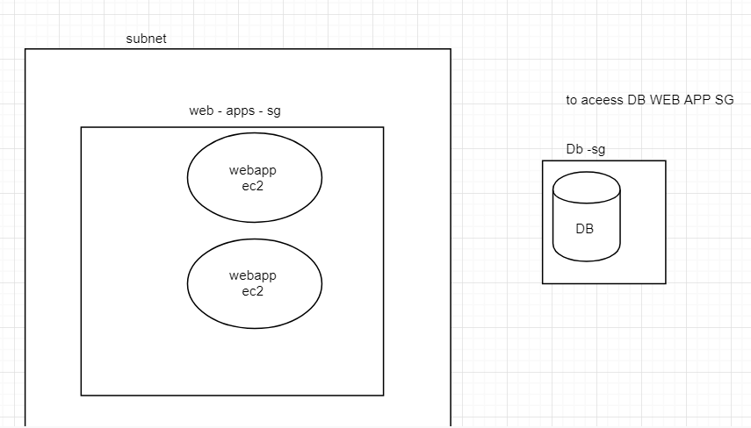,

In the above fig DB is in private subnet , my ec2 is in public subnet if my ec2 instances wants toa cess DB then how to configure security grps .

If I give ip address of each ec2 instances when I increase my ec2 instances we need to give those many Ip adresses (as inbound to acess DB)

In such cases I give security groups of the web apps in **db source.**

--------------------------------------------------------------------------------------------------------------------------------------

**NACL :**

It is a virtuall firewall which secures subnets

It has inbound/outbound rules

Nacl’s are **stateless**. (i.e inbound traffic

One subnet must have one NACL

Multiple subnet can have same NACl *D

Nacl has explicit allow/deny ( i.e if we want to block all traffic from specific source we can do it.

**Understanding NAcl rules :**

**Every** rule must have unique rule number

Rules are executed in ascending order

When a matcing rule is found the action against that rule is applied ( i.e if it say allows it allow else if it says deny it deny )

When matching rule is found that rule is applied it wont go to next rule.

Note : Give sufficient spaces between rule numbers. ( ex : have rule numbers like 100 , 200 , 250)

**Default NACL :** This is implicitly created when VPC is created and by default all subnets are associated to Default Nacl

By default, default nacl allows all inbound & outbound ( when u create vpc default nacl cretates *D ( subnets uses Nacl obviously ec2 instances uses (for my clarify *D)

Along with default we can maintain custom Nacl’s.

Default rules of custom nacl is deny all inbound & outbound.

17-10-18

Czlb: (cross zone load balancing)

If web server is storing stay of a client then stickiness is required ( ex ; amazon cart products are stores in web server)

By default it is enabled , if enabled every Ec2 gets same amount of load

If disabled every zone gets same amount of load

( if zone 1 is having 10 ec2 , and zone 2 is having 5 ec2 if enabled every ec2 gets same traffic , if disabled 50 % of traffic gets to zone1 and 50% of traffic gets to Zone2)

ALB : ( Application load balancer)

* Used for Microservices applications
* It has path based o/p.
* The traffic based on a path and port

**IQ)**

We want to Load balancer which does routing based on a path and port

we have to use ALB/NLB

I TAKE GROUP EC2 INSTANCE WHICH RUNS ORDERS APPLICATION

I TAKE GROUP EC2 INSTANCE WHICH RUNS PAYEMENTS APPLICATION

I WILL CREATE RULE :_ WHEN ROUTE A TRAFFIC TO ORDERS AND WHEN TO ROUTE A TRAFFIC TO PAYEMENTS , IF PATH CONTAINS ORDER THEN GO TO ORDERS ,PATH CNTAINS PAYEMENTS THEN ROUTE TO PAYEMNTS

ALB runs on port 80

Create target group :

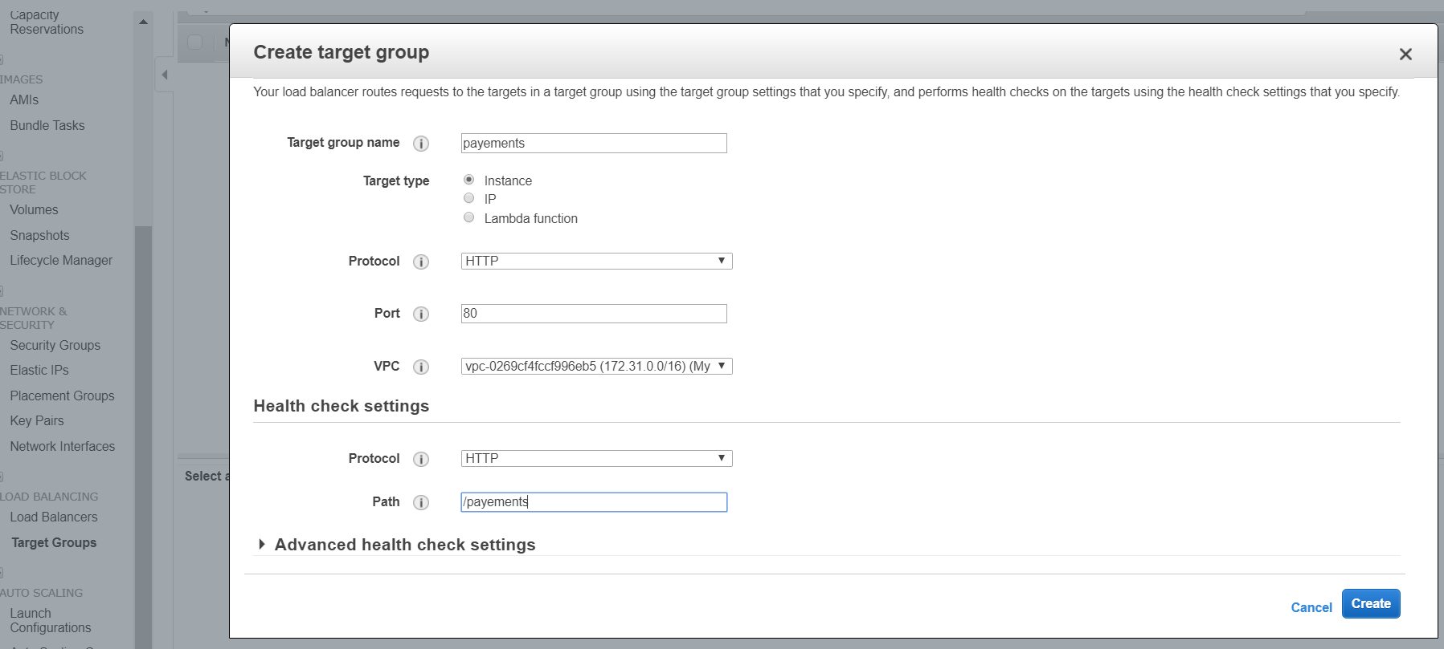

Then create – targets – edit – select the particular one

Configure ALB

Create ALB :

GO TO LISTENERS UNDER alb - PUT RULES : NAME :/PAYEMENTS

Nlb :Choose network load balancer when you need ultra high performance

There are capable of handling millions of requests per second

Auto scalling:

* Auto scaling is used to manage Amazon ec2 capacity automatically . maintain the right number of instances for your application , -operate a healthy group of instances and scale it according to your needs.
* Autoscalling is free , if auto scaling launches additional resources for that we need to pay
* It is cost effective , it always maintains the exact capacity we need to serve the traffic.
* It manages health checks if any ec2 found unhealthy it terminates and launches new Ec2.
* ELB can be integrated with auto scalling such that Ec2 instances are dynamically added or removed.

If auto scaling wants to launch instance :

Launch configuration : it’s a template which contains following details

* -ami
* -instance type
* volume type and size
* Sg (security group
* Iam role
* Private key or key pair

Auto scalling wil use launch config for launching ec2 instances in auto scalling group.

Create Ami that should contain our appinstalled and configured

RDS:

Rds has automated backup’s with default retention 7 days and max is 35

When backups are performed there is brief suspension of i/o operations which leads to performance problems , ( if you want to fix this problems, if we have multiple Az enabled , backups are taken on a standby which doesnot impact performance of primary db.

It supports point- in time recovery ( if I want to restore my db in, specific day, specific hour,specific minute and specific second

We also can make manualbackups if required

Rds- dashboard

Step 1: make sure vpc and subnets are configured

Create a subnet group where we want to launch RDS (

(Rds must go in to private subnet ,

Create subnet group ( this subnet group contains private subnet))

Apps can connect to db using iam role or iam user.

Take backup in non business hours sothat customers wont impact.

Read replica : it is another db which is in sync

Multi az deployement

Supports read replicas.

RDS notifications :

Event subscription :

24-10-19

DYNAMO DB :

* Highly scalable, highly durable , no sql db from amazon
* Can handle unlimited amount of data and throughput
* Good option for large data sets
* Data is stored as json documents
* If we properly design our schema, we can fit all our data into 1 table
* Create table
* Follows dynamic schema
* We have app we are using rds , we want to add new column , if we want new column in the miidle it will throw exception, as dynamo db follows dynamic schema we can add column

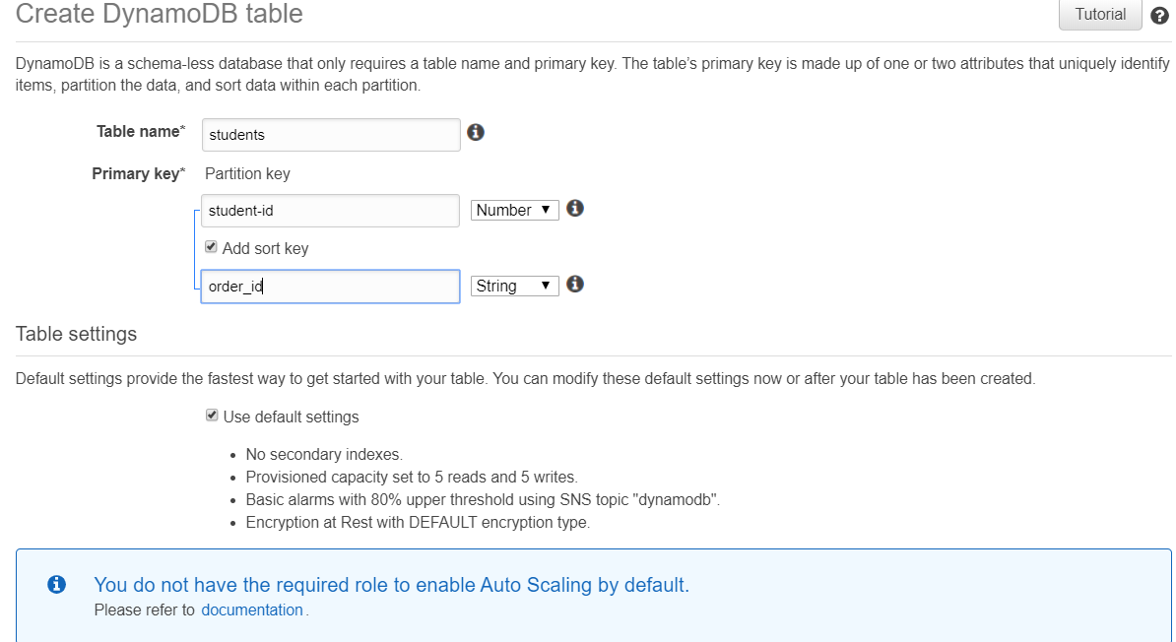

* Items are known as records
* Attribtes are known as columns
* Increase read and write capacity units it scales

RED SHIFT

* Highly available ,highly scalable data warehousing solution from AWS
* It is widley used in reporting and analytics
* It is relational
* Red shift is called as columunar data base
* Specially designed for reporting 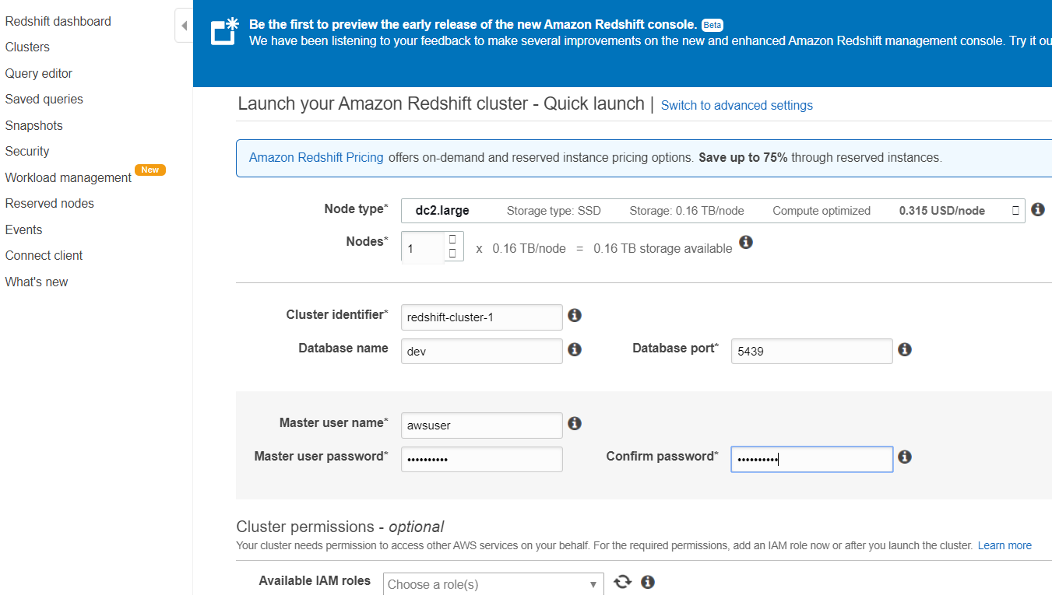
* Always uses agreegate f/n ‘s like mean ,average,max.

1 r 2 questions in certific

**Elastic cache:**

* Highly available ,highly scalable durable
* Stores data in RAM , data acess is fast
* Cache readaing disk is not there so with ram it is fast
* Used to improve app performance

Q) we have entreprise app and wants to store API tokens for better performance.

1. Rds
2. DYnamobd
3. S3
4. Elastic cache

Ans ) dynamo and elastic cache

Elastic cache supports 2 engines

- redis

- memcached